[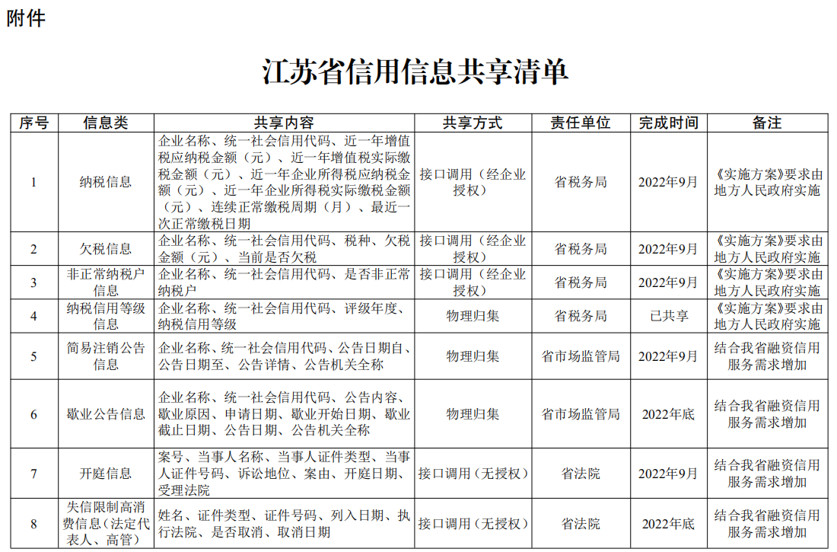](http://www.jiangsu.gov.cn/picture/0/2207221154354194308.png" \t "http://www.jiangsu.gov.cn/art/2022/7/22/_blank)

[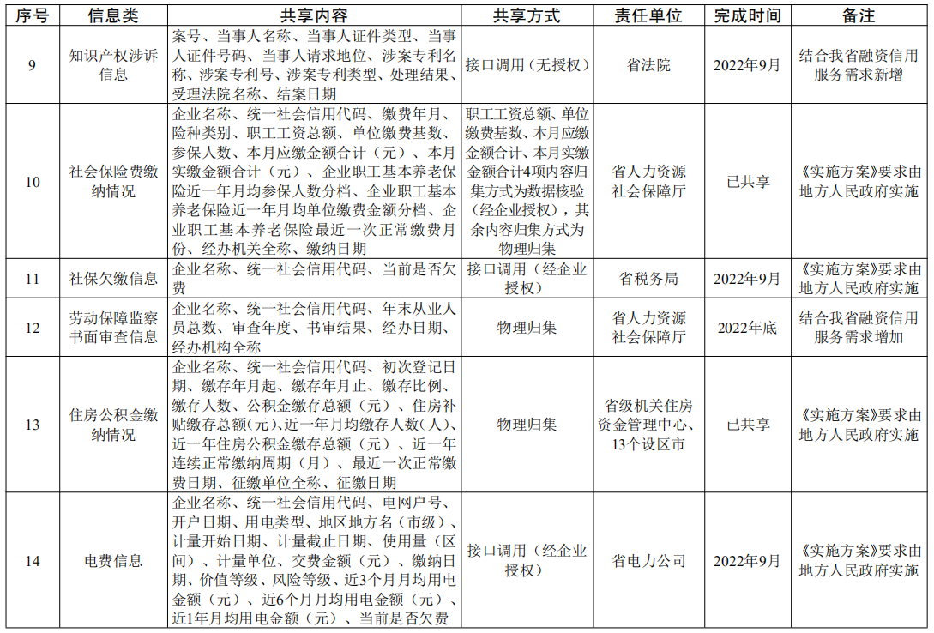](http://www.jiangsu.gov.cn/picture/0/2207221154354027586.png)

[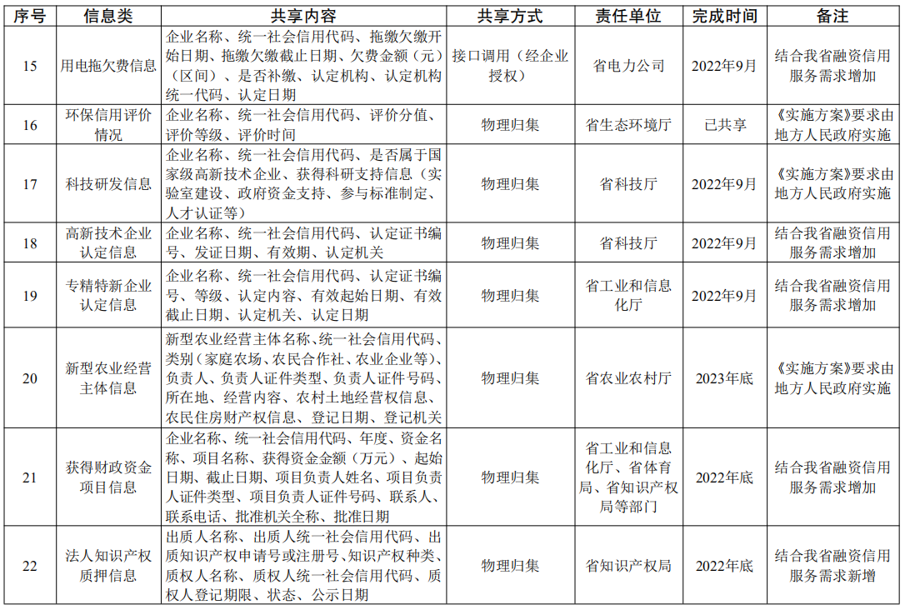](http://www.jiangsu.gov.cn/picture/0/2207221154353856184.png)

[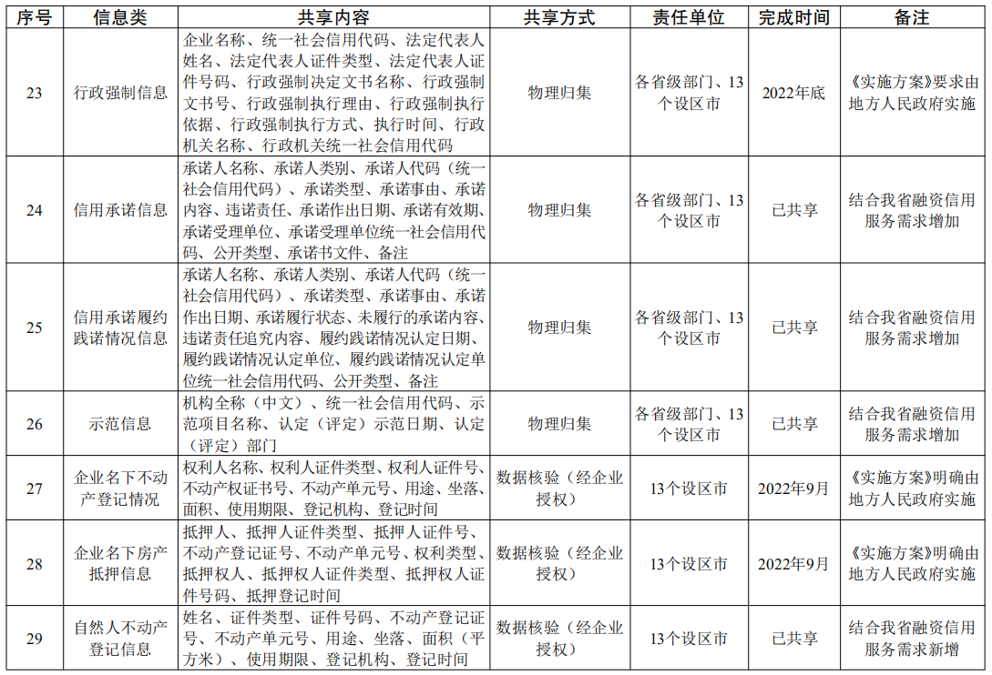](http://www.jiangsu.gov.cn/picture/0/2207221154353679565.png)

[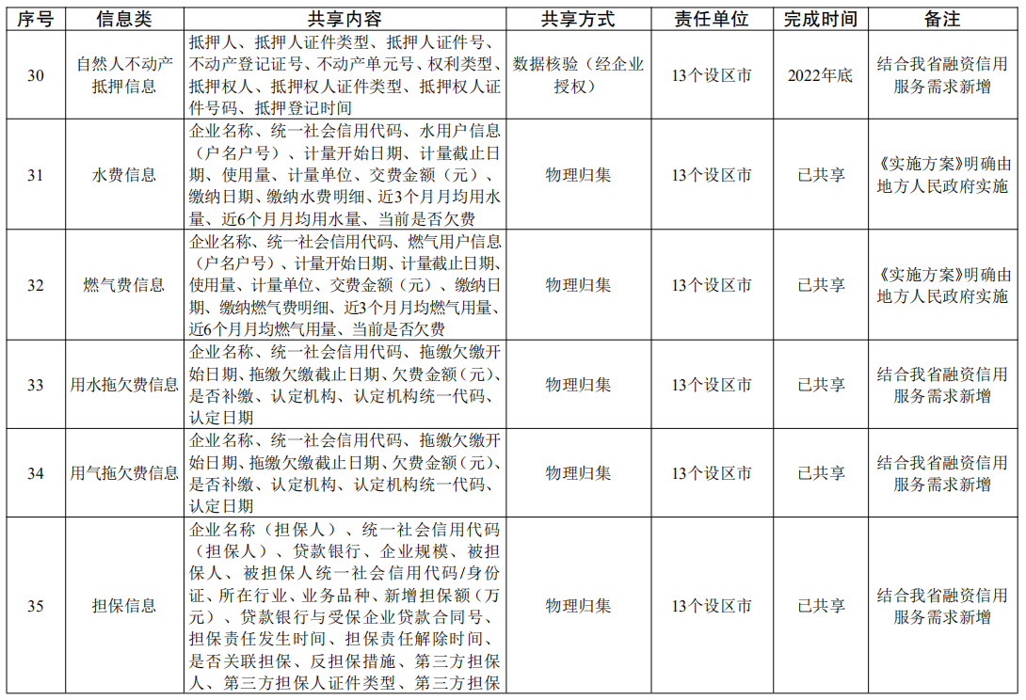](http://www.jiangsu.gov.cn/picture/0/2207221154353502323.png)

[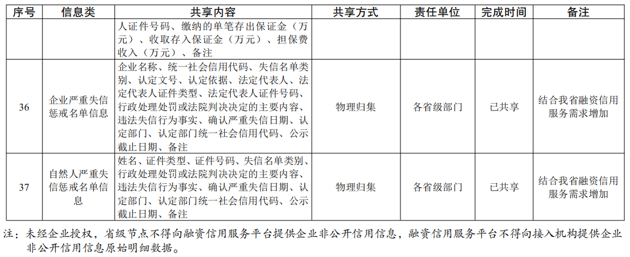](http://www.jiangsu.gov.cn/picture/0/2207221154353265496.png)